Sphere-Based Subtraction

Definition
# Source: AI Source: Provided by: [Data Path: Persons Table -> ID Column: 1, Name_En Column: Motasem Essam] -> From: [ChatGPT] on [7/25/2026]
Sphere-Based Subtraction is a type of composite solid formation in which one or more geometric portions are removed from an original sphere or a sphere-based solid to create cavities, holes, depressions, grooves, or other cutout shapes.
The removed portions may have the shape of spheres, cylinders, cones, prisms, pyramids, or other geometric solids.
The resulting object is called a sphere-based solid formed by subtraction.

Simple Definition
# Source: AI Source: Provided by: [Data Path: Persons Table -> ID Column: 1, Name_En Column: Motasem Essam] -> From: [ChatGPT] on [7/25/2026]
Sphere-Based Subtraction means removing one or more geometric portions from a spherical solid to create a new three-dimensional shape.
Example: Removing a smaller sphere from the center of a larger sphere to create a hollow spherical shell.

Geometric Representation
# Source: AI Source: Provided by: [Data Path: Persons Table -> ID Column: 1, Name_En Column: Motasem Essam] -> From: [ChatGPT] on [7/25/2026]
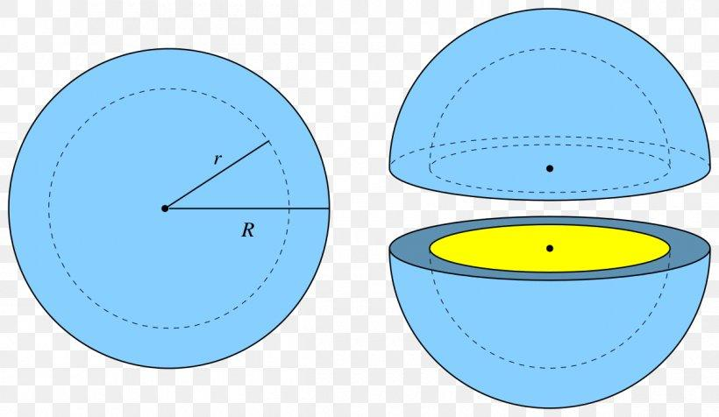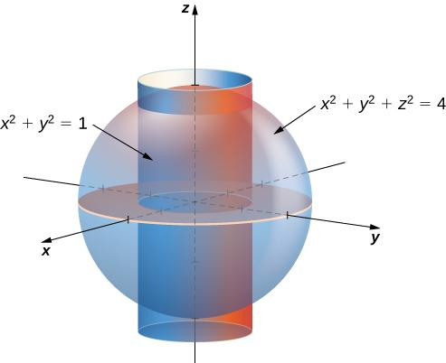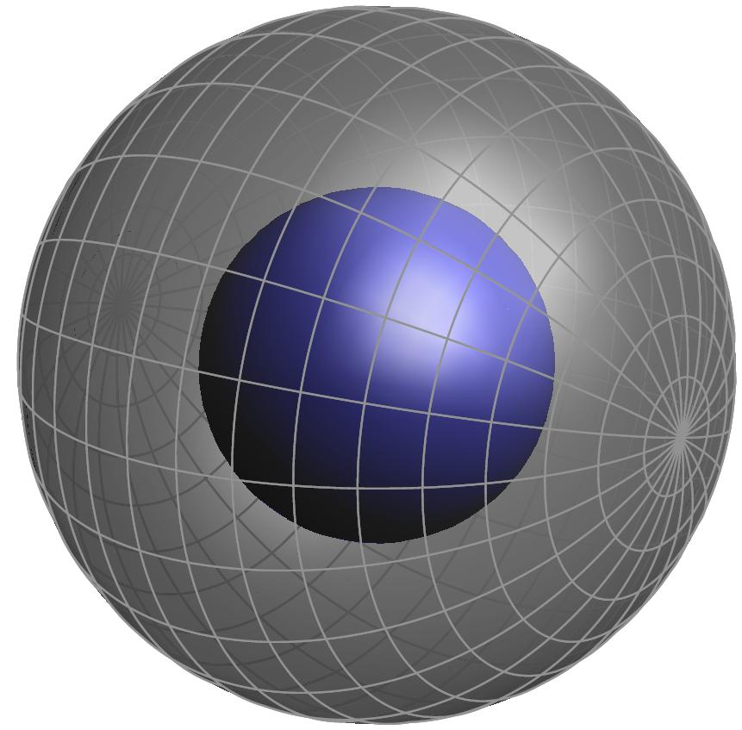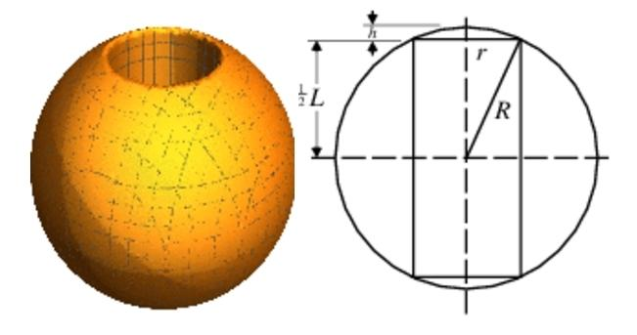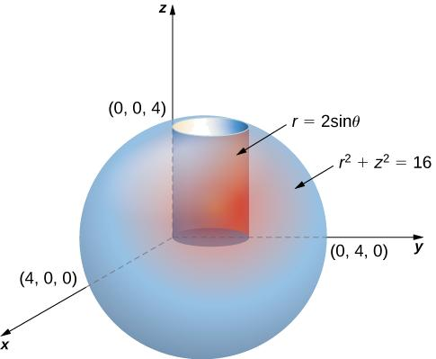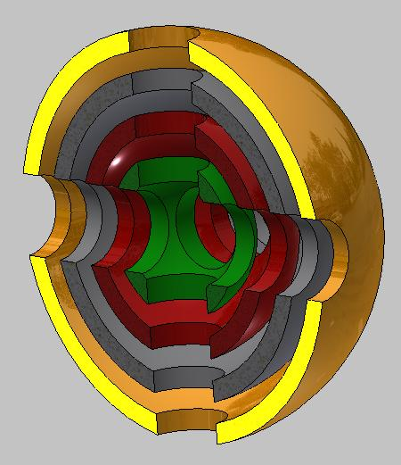
Main Components
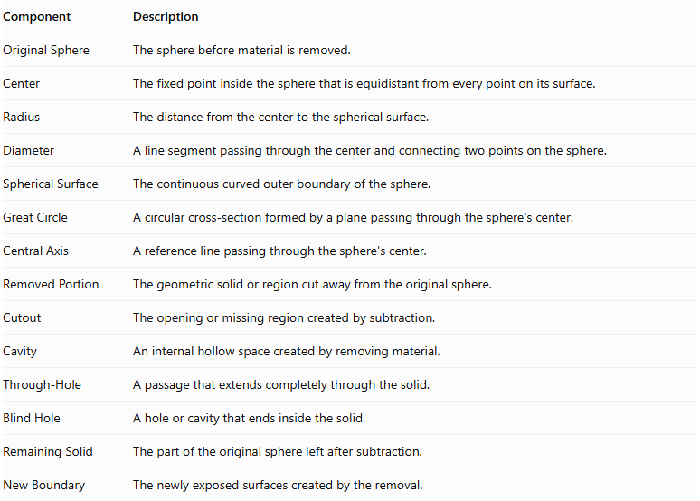
Component | Description
Original Sphere | The sphere before material is removed.
Center | The fixed point inside the sphere that is equidistant from every point on its surface.
Radius | The distance from the center to the spherical surface.
Diameter | A line segment passing through the center and connecting two points on the sphere.
Spherical Surface | The continuous curved outer boundary of the sphere.
Great Circle | A circular cross-section formed by a plane passing through the sphere's center.
Central Axis | A reference line passing through the sphere's center.
Removed Portion | The geometric solid or region cut away from the original sphere.
Cutout | The opening or missing region created by subtraction.
Cavity | An internal hollow space created by removing material.
Through-Hole | A passage that extends completely through the solid.
Blind Hole | A hole or cavity that ends inside the solid.
Remaining Solid | The part of the original sphere left after subtraction.
New Boundary | The newly exposed surfaces created by the removal.

Types of Sphere-Based Subtraction

Spherical Subtraction from a Sphere
# Source: AI Source: Provided by: [Data Path: Persons Table -> ID Column: 1, Name_En Column: Motasem Essam] -> From: [ChatGPT] on [7/25/2026]
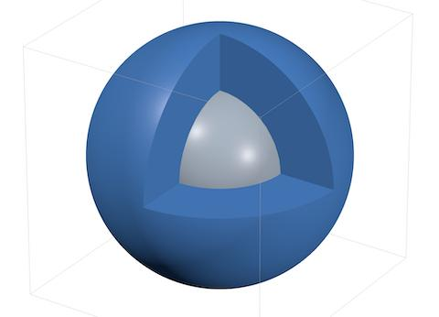
A smaller spherical portion is removed from a larger sphere.
Examples:
- Concentric spherical cavity.
- Eccentric spherical cavity.
- Central spherical cavity.
- Off-center spherical cavity.
- Spherical through-opening.
- Partial spherical cavity.

Cylindrical Subtraction from a Sphere
# Source: AI Source: Provided by: [Data Path: Persons Table -> ID Column: 1, Name_En Column: Motasem Essam] -> From: [ChatGPT] on [7/25/2026]
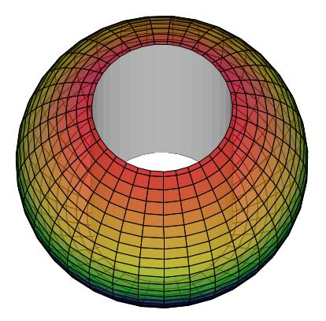
A cylindrical portion is removed from a sphere.
Examples:
- Central cylindrical through-hole.
- Off-center cylindrical through-hole.
- Vertical cylindrical hole.
- Horizontal cylindrical tunnel.
- Cylindrical blind hole.
- Cylindrical cavity.

Conical Subtraction from a Sphere
# Source: AI Source: Provided by: [Data Path: Persons Table -> ID Column: 1, Name_En Column: Motasem Essam] -> From: [ChatGPT] on [7/25/2026]
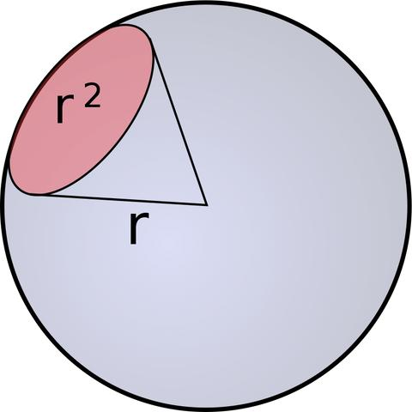
A conical portion is removed from a sphere.
Examples:
- Central conical cavity.
- Off-center conical cavity.
- Conical depression.
- Conical blind cavity.
- Conical through-cut.

Rectangular Prism Subtraction from a Sphere
# Source: AI Source: Provided by: [Data Path: Persons Table -> ID Column: 1, Name_En Column: Motasem Essam] -> From: [ChatGPT] on [7/25/2026]
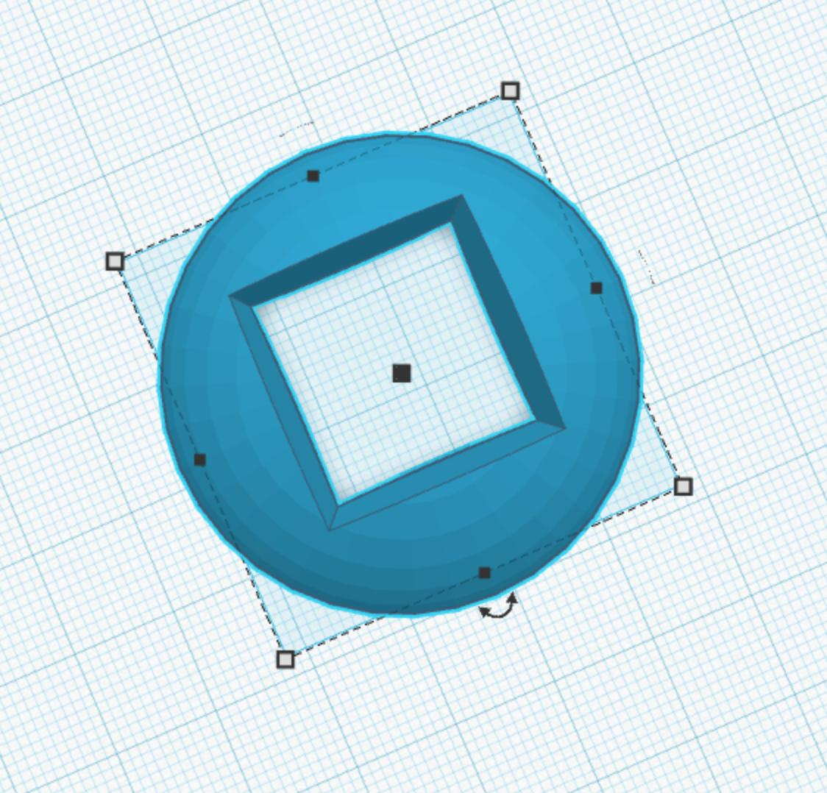
A rectangular-prism-shaped portion is removed from a sphere.
Examples:
- Rectangular cavity.
- Rectangular notch.
- Rectangular through-cut.
- Rectangular side opening.
- Rectangular slot.

Triangular Prism Subtraction from a Sphere
# Source: AI Source: Provided by: [Data Path: Persons Table -> ID Column: 1, Name_En Column: Motasem Essam] -> From: [ChatGPT] on [7/25/2026]
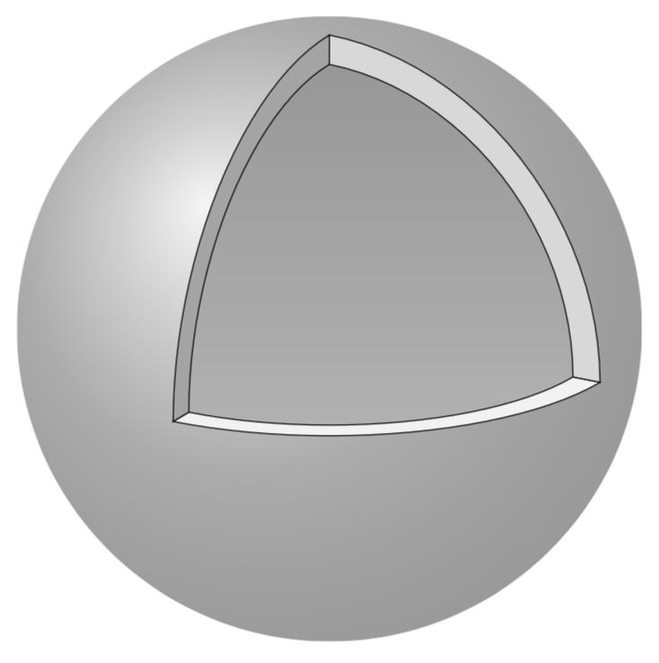
A triangular-prism-shaped portion is removed from a sphere.
Examples:
- Triangular cavity.
- Wedge-shaped cutout.
- Triangular notch.
- Triangular through-cut.
- Triangular side opening.

Pyramidal Subtraction from a Sphere
# Source: AI Source: Provided by: [Data Path: Persons Table -> ID Column: 1, Name_En Column: Motasem Essam] -> From: [ChatGPT] on [7/25/2026]
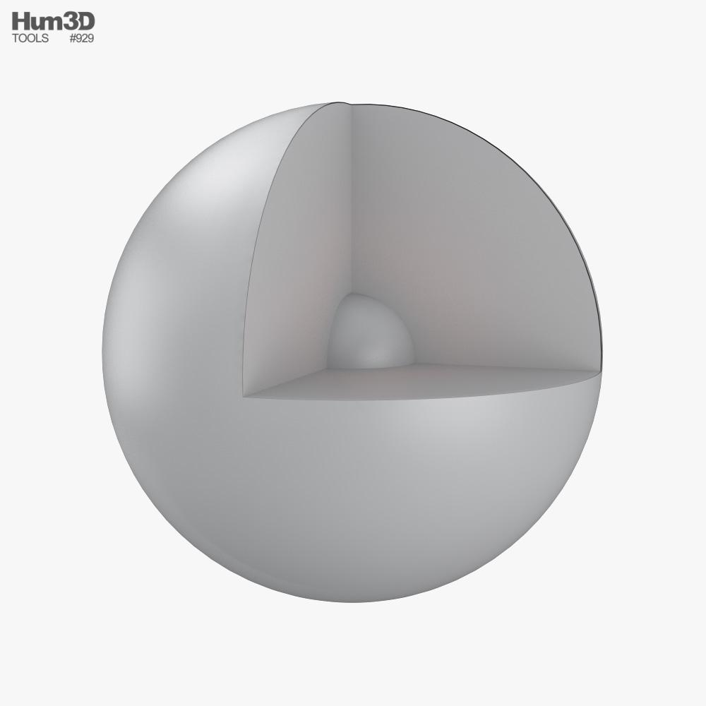
A pyramidal portion is removed from a sphere.
Examples:
- Square-pyramidal cavity.
- Triangular-pyramidal cavity.
- Central pyramidal cutout.
- Off-center pyramidal cutout.
- Pyramidal depression.

Multiple-Shape Subtraction from a Sphere
# Source: AI Source: Provided by: [Data Path: Persons Table -> ID Column: 1, Name_En Column: Motasem Essam] -> From: [ChatGPT] on [7/25/2026]
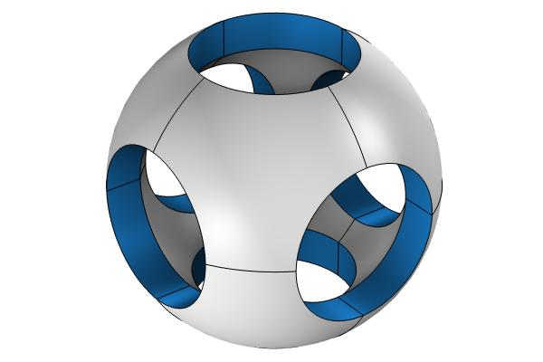
Two or more portions are removed from the same sphere.
Examples:
- Multiple cylindrical holes.
- Spherical cavity with cylindrical hole.
- Conical depression with rectangular notch.
- Multiple mixed-shape cutouts.

Classification by Location of Subtraction
# Source: AI Source: Provided by: [Data Path: Persons Table -> ID Column: 1, Name_En Column: Motasem Essam] -> From: [ChatGPT] on [7/25/2026]
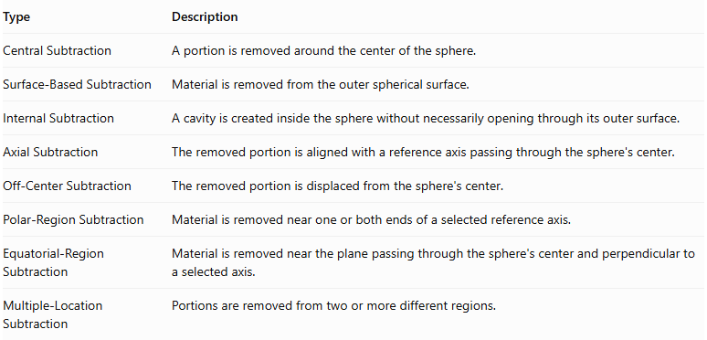
Type | Description
Central Subtraction | A portion is removed around the center of the sphere.
Surface-Based Subtraction | Material is removed from the outer spherical surface.
Internal Subtraction | A cavity is created inside the sphere without necessarily opening through its outer surface.
Axial Subtraction | The removed portion is aligned with a reference axis passing through the sphere's center.
Off-Center Subtraction | The removed portion is displaced from the sphere's center.
Polar-Region Subtraction | Material is removed near one or both ends of a selected reference axis.
Equatorial-Region Subtraction | Material is removed near the plane passing through the sphere's center and perpendicular to a selected axis.
Multiple-Location Subtraction | Portions are removed from two or more different regions.

Classification by Subtraction Method
# Source: AI Source: Provided by: [Data Path: Persons Table -> ID Column: 1, Name_En Column: Motasem Essam] -> From: [ChatGPT] on [7/25/2026]
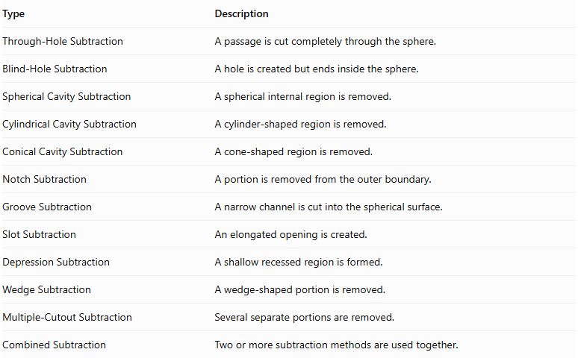
Type | Description
Through-Hole Subtraction | A passage is cut completely through the sphere.
Blind-Hole Subtraction | A hole is created but ends inside the sphere.
Spherical Cavity Subtraction | A spherical internal region is removed.
Cylindrical Cavity Subtraction | A cylinder-shaped region is removed.
Conical Cavity Subtraction | A cone-shaped region is removed.
Notch Subtraction | A portion is removed from the outer boundary.
Groove Subtraction | A narrow channel is cut into the spherical surface.
Slot Subtraction | An elongated opening is created.
Depression Subtraction | A shallow recessed region is formed.
Wedge Subtraction | A wedge-shaped portion is removed.
Multiple-Cutout Subtraction | Several separate portions are removed.
Combined Subtraction | Two or more subtraction methods are used together.

Classification by Number and Arrangement
# Source: AI Source: Provided by: [Data Path: Persons Table -> ID Column: 1, Name_En Column: Motasem Essam] -> From: [ChatGPT] on [7/25/2026]
- Single Subtraction: One portion is removed from the sphere.
- Double Subtraction: Two portions are removed.
- Multiple Subtraction: Three or more portions are removed.
- Repeated Subtraction: Similar cutouts are repeated in different locations.
- Axial Subtraction: Removed portions are aligned along a reference axis.
- Radial Subtraction: Cutouts are arranged around a central point or axis.
- Symmetrical Subtraction: Removed portions are arranged symmetrically.
- Asymmetrical Subtraction: Removed portions are arranged without symmetry.
- Uniform Subtraction: Repeated cutouts have consistent dimensions and spacing.
- Non-Uniform Subtraction: Cutouts differ in dimensions or spacing.
- Mixed-Shape Subtraction: Different geometric shapes are removed from the same sphere.

Mathematical Properties and Formulas

Volume of the Original Sphere
# Source: AI Source: Provided by: [Data Path: Persons Table -> ID Column: 1, Name_En Column: Motasem Essam] -> From: [ChatGPT] on [7/25/2026]
$$V_{sphere}=\frac{4}{3}πR^{3}$$
Where:
- $R$ = radius of the original sphere.
- $π≈3.14159$.

Surface Area of the Original Sphere
# Source: AI Source: Provided by: [Data Path: Persons Table -> ID Column: 1, Name_En Column: Motasem Essam] -> From: [ChatGPT] on [7/25/2026]
$${SA}_{sphere}=4πR^{2}$$
The sphere has one continuous curved outer surface and no flat faces.

Remaining Volume After Subtraction
# Source: AI Source: Provided by: [Data Path: Persons Table -> ID Column: 1, Name_En Column: Motasem Essam] -> From: [ChatGPT] on [7/25/2026]
$$V_{remaining}=V_{original}-V_{removed}$$
For multiple non-overlapping removed portions:
$$V_{remaining}=V_{original}-\sum_{i=1}^{n}{V_{i}}$$
If removed portions overlap, their intersections must not be subtracted more than once.

Volume of Common Removed Shapes
# Source: AI Source: Provided by: [Data Path: Persons Table -> ID Column: 1, Name_En Column: Motasem Essam] -> From: [ChatGPT] on [7/25/2026]
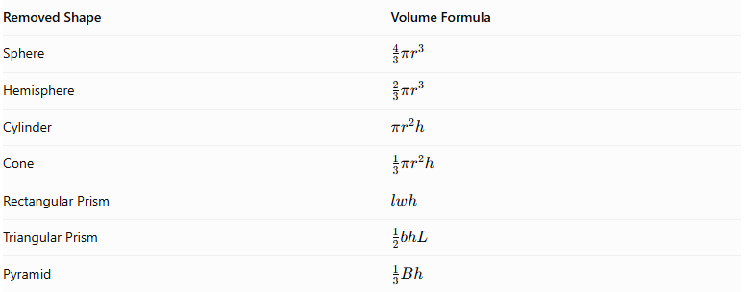
Removed Shape | Volume Formula
Sphere | $$\frac{4}{3}πr^{3}$$
Hemisphere | $$\frac{2}{3}πr^{3}$$
Cylinder | $$πr^{2}h$$
Cone | $$\frac{1}{3}πr^{2}h$$
Rectangular Prism | $$lwh$$
Triangular Prism | $$\frac{1}{2}bhL$$
Pyramid | $$\frac{1}{3}Bh$$

Surface Area After Subtraction
# Source: AI Source: Provided by: [Data Path: Persons Table -> ID Column: 1, Name_En Column: Motasem Essam] -> From: [ChatGPT] on [7/25/2026]
$${SA}_{remaining}={SA}_{original}-{SA}_{removed boundary}+{SA}_{newly exposed}$$
This means:
- Subtract the portions of the original spherical surface that become openings.
- Add the newly exposed surfaces inside the cavities or cutouts.
- Keep all original surfaces that remain exposed.
Important: The surface area of the removed solid is not automatically the surface area to subtract. The actual intersection between the removed portion and the sphere determines the surface-area changes.

Worked Examples

Example 1: Sphere with a Concentric Spherical Cavity
# Source: AI Source: Provided by: [Data Path: Persons Table -> ID Column: 1, Name_En Column: Motasem Essam] -> From: [ChatGPT] on [7/25/2026]
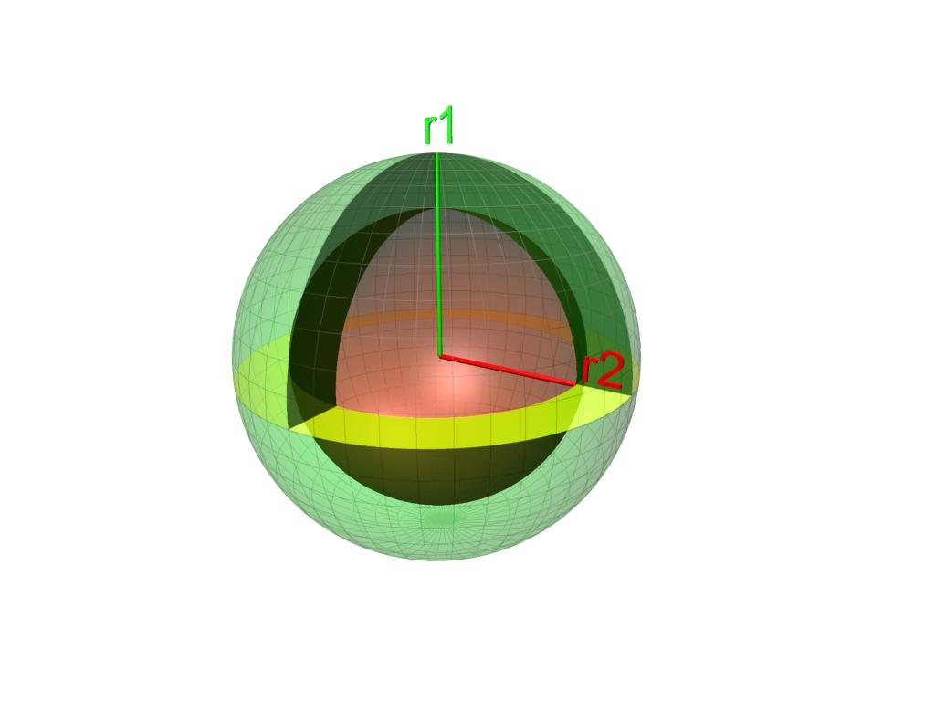
Given:
- Original sphere radius: $R=6 cm$
- Removed spherical cavity radius: $r=3 cm$
- The cavity is concentric with the original sphere and completely enclosed.
Step 1: Calculate the original sphere volume.
$$V_{original}=\frac{4}{3}π(6)^{3}=288π$$
$$V_{original}≈904.78{ cm}^{3}$$
Step 2: Calculate the removed sphere volume.
$$V_{removed}=\frac{4}{3}π(3)^{3}=36π$$
$$V_{removed}≈113.10{ cm}^{3}$$
Step 3: Calculate the remaining volume.
$$V_{remaining}=288π-36π$$
$$\boxed{V_{remaining}=252π≈791.68{ cm}^{3}}$$
Step 4: Calculate the original outer surface area.
$${SA}_{outer}=4π(6)^{2}=144π$$
Step 5: Calculate the new internal surface area.
$${SA}_{inner}=4π(3)^{2}=36π$$
Step 6: Calculate the total surface area.
The hollow sphere has both an outer spherical surface and an inner spherical surface.
$${SA}_{remaining}=144π+36π$$
$$\boxed{{SA}_{remaining}=180π≈565.49{ cm}^{2}}$$
Conclusion: Removing a concentric spherical cavity creates a hollow spherical solid with two spherical boundary surfaces.

Example 2: Sphere with a Central Cylindrical Through-Hole
# Source: AI Source: Provided by: [Data Path: Persons Table -> ID Column: 1, Name_En Column: Motasem Essam] -> From: [ChatGPT] on [7/25/2026]
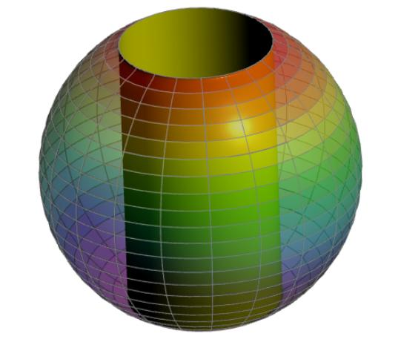
Given:
- Original sphere radius: $R=5 cm$
- Cylindrical hole radius: $r=3 cm$
- The cylindrical hole passes through the center of the sphere.
Step 1: Calculate the original sphere volume.
$$V_{original}=\frac{4}{3}π(5)^{3}=\frac{500π}{3}$$
Step 2: Calculate the length of the cylindrical hole inside the sphere.
Using the Pythagorean theorem:
$$\frac{h}{2}=\sqrt{R^{2}-r^{2}}$$
$$\frac{h}{2}=\sqrt{25-9}=4$$
$$h=8 cm$$
Step 3: Calculate the removed volume.
The removed region is the part of the cylinder lying inside the sphere. Its volume is:
$$V_{removed}=\int_{-4}^{4}{π}(3)^{2},dx$$
However, the cylinder's full cross-section is not contained in the sphere at every position. The remaining cross-sectional area is more directly calculated using circular washers:
$$V_{remaining}=\int_{-4}^{4}{π}(16-x^{2}),dx$$
$$V_{remaining}=\frac{256π}{3}$$
Therefore:
$$V_{removed}=\frac{500π}{3}-\frac{256π}{3}=\frac{244π}{3}$$
Step 4: Calculate the remaining volume.
$$\boxed{V_{remaining}=\frac{256π}{3}≈268.08{ cm}^{3}}$$
Step 5: Calculate the remaining spherical surface area.
The remaining outer spherical surface is a spherical band.
$${SA}_{outer}=4πR\sqrt{R^{2}-r^{2}}$$
$${SA}_{outer}=4π(5)(4)=80π$$
Step 6: Calculate the newly exposed cylindrical surface area.
$${SA}_{inner}=2πrh$$
$${SA}_{inner}=2π(3)(8)=48π$$
Step 7: Calculate the total remaining surface area.
$${SA}_{remaining}=80π+48π$$
$$\boxed{{SA}_{remaining}=128π≈402.12{ cm}^{2}}$$
Conclusion: A cylindrical through-hole passing through the center of a sphere produces a ring-shaped solid known as a napkin ring. Its remaining volume depends on the height of the ring, rather than directly on the original sphere's radius.

Important Characteristics
# Source: AI Source: Provided by: [Data Path: Persons Table -> ID Column: 1, Name_En Column: Motasem Essam] -> From: [ChatGPT] on [7/25/2026]
- Sphere-Based Structure: The original solid is a sphere or a composite solid containing a sphere.
- Material Removal: One or more geometric portions are removed from the original solid.
- Volume Reduction: The remaining volume is smaller than the original volume.
- Surface Modification: New internal or external surfaces may appear after subtraction.
- Variable Cutout Shapes: Removed portions can be spherical, cylindrical, conical, pyramidal, prismatic, or mixed.
- Different Cutout Locations: Subtraction can occur at the center, outer surface, polar regions, equatorial region, or interior.
- Symmetrical or Asymmetrical Design: Cutouts may be centered or positioned off-center.
- Curved Boundary Formation: The remaining solid may contain spherical, cylindrical, conical, and planar surfaces.
- Complex Geometric Results: Multiple subtraction operations can produce hollow, perforated, or irregular spherical structures.

Comparison with Other Subtraction Types
# Source: AI Source: Provided by: [Data Path: Persons Table -> ID Column: 1, Name_En Column: Motasem Essam] -> From: [ChatGPT] on [7/25/2026]
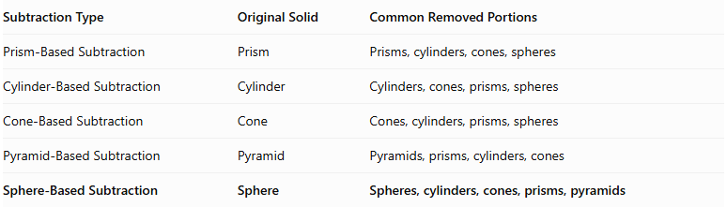
Subtraction Type | Original Solid | Common Removed Portions
Prism-Based Subtraction | Prism | Prisms, cylinders, cones, spheres
Cylinder-Based Subtraction | Cylinder | Cylinders, cones, prisms, spheres
Cone-Based Subtraction | Cone | Cones, cylinders, prisms, spheres
Pyramid-Based Subtraction | Pyramid | Pyramids, prisms, cylinders, cones
Sphere-Based Subtraction | Sphere | Spheres, cylinders, cones, prisms, pyramids

Applications
# Source: AI Source: Provided by: [Data Path: Persons Table -> ID Column: 1, Name_En Column: Motasem Essam] -> From: [ChatGPT] on [7/25/2026]
- Mechanical Engineering: Designing spherical housings, hollow components, and specialized mechanical parts.
- Manufacturing: Creating spherical cavities, cylindrical passages, and recessed spherical surfaces.
- Automotive Engineering: Producing spherical joints, bearing housings, and specialized component openings.
- Architecture: Designing spherical structures with openings and internal cavities.
- Product Design: Creating decorative spherical objects and hollow products.
- CAD Modeling: Constructing complex three-dimensional objects using Boolean subtraction operations.
- Education: Teaching volume subtraction, spherical geometry, and three-dimensional geometric transformations.

Key Points
# Source: AI Source: Provided by: [Data Path: Persons Table -> ID Column: 1, Name_En Column: Motasem Essam] -> From: [ChatGPT] on [7/25/2026]
- Sphere-Based Subtraction removes one or more geometric portions from an original sphere.
- Removed portions can have different geometric shapes.
- Subtraction can create holes, cavities, depressions, grooves, and openings.
- The remaining volume equals the original volume minus the removed volume, accounting for overlapping cutouts.
- Surface area must account for removed original surfaces and newly exposed surfaces.
- A blind hole ends inside the sphere, while a through-hole passes completely through it.
- A concentric spherical cavity produces a hollow spherical solid.
- A central cylindrical through-hole produces a napkin ring.
- The location, dimensions, and shape of each cutout determine the final geometry.

Conclusion
# Source: AI Source: Provided by: [Data Path: Persons Table -> ID Column: 1, Name_En Column: Motasem Essam] -> From: [ChatGPT] on [7/25/2026]
Sphere-Based Subtraction is a method of forming composite solids by removing one or more geometric portions from an original sphere. It can produce hollow spheres, spherical cavities, cylindrical passages, and complex structures containing multiple cutouts.
Its mathematical analysis involves calculating the remaining volume and identifying all exposed surfaces after subtraction. It is an important concept in solid geometry, engineering, manufacturing, product design, and three-dimensional modeling.

